DAD 220 Project Two Template

Overview
Review the scenario for this activity in the guidelines and rubric. Then complete the steps below as you work through the directions for this activity. Replace the bracketed text with your screenshots and responses to the prompts. Size each screenshot and its explanation to fit approximately one-quarter of the page with the description written below the screenshot. Review the Template Screenshot Example linked in the guidelines and rubric for this assignment to see an example of how screenshots for your assignment should look.

RMA Report
Write a report to respond to the manager’s requests. In the report, you should complete the following actions:

- Summarize the data you’ve been working with.
- Identify key information that will help the company streamline operations.

Your report should explain your findings in a way nontechnical stakeholders can understand and use.

Use the steps below to capture the required data and produce the analysis report.

- Begin by writing SQL commands to capture specific usable data for your analysis. You already preloaded the data you need into Codio.
- Specifically, the product manager wants you to complete the following analysis:

  - Analyze the number of returns by state and describe findings to include in your report.

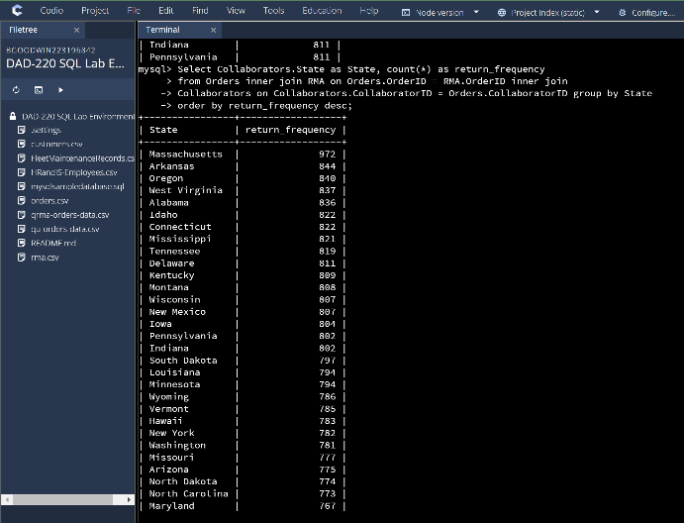
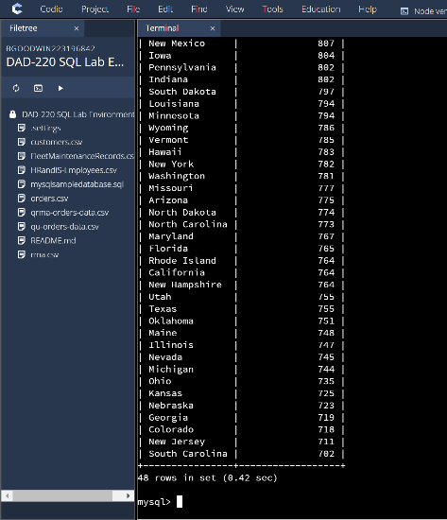
I used the select command to choose states and the count all command to show the number of times each state was used in the return. It then needed to be connected to the Collaborators table through the Orders table to the RMA table to find the number of returns. I Finally had it returned a new table showing the states and the number of returns each state had, this is ordered from most to least based on number of returns. Massachusetts’, Arkansas, and Oregan has the most returns and Colorado, New Jersey and South Carolina have the least number of returns.

  - Analyze the percentage of returns by product type and describe findings to include in your report.

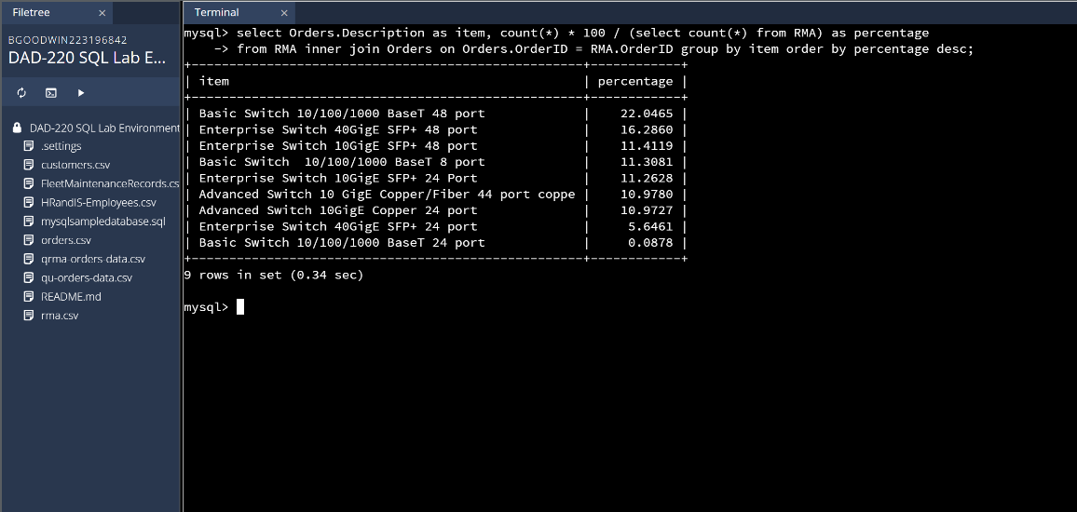
I selected the total number of each item from the Orders table and divided it by the times that the item was returned by connecting it with the RMA table. I then had the database times it by 100 as that would return the percentage of the times each item was returned. This table shows that Basic Switch 10/100/1000 BaseT 48 port was returned the most at 22.0456 percent of the time and
Basic Switch 10/100/1000 BaseT 24 port was returned the least at 0.0878 percent.

- Write a report to clearly summarize your RMA data analysis for stakeholders. When you summarize the results, consider the following questions:

  - How does the data provide the product manager with usable information?
  - What are the potential flaws in the data that has been presented?
  - Are there any limitations on your conclusions or any other ways of looking at your findings that you haven’t considered? Clearly communicate your findings to stakeholders.

This data is useful to not only the product manager but to the rest of the company as it provides a way in which we can look up data based on specific guidelines. Specifically, the ability to see which states have the most returns along with the percentage of the items returned can be used to see where potential problems are occurring. If we can trouble shoot why people are returning these items, we may be able to change the product if necessary or fix potential problems with the customers before the product needs to be returned. It can also show us where we do the most business so we can have warehouses or products available to cut down on transportation costs. The flaws of this data are that it doesn’t show why the customers are returning the products or what businesses buy our products the most. We can only see the number of returned and the products that were specifically returned, It also doesn’t show how these transactions were handled or who they were handled by. Depending on the sales rep the problem could be fixed or replaced, if the sales rep did not handle the transaction appropriately it could cost us a potential client. The data is limited in that it doesn’t show the cost of the making of the products, the cost of replacement or the revenue we have made over the year. It fails to look at operating costs or the materials needed to continue making and selling our product. While the data is useful, it only provides a starting point for looking at returns further, with a larger scope.

